# Laboratory 1 – Introduction to MATLAB for Signals and Systems

Name: Hao Liu

Student #: 218703991

Date: 2024/10/03 Location: Virtually

Table of Contents

Laboratory 1 – Introduction to MATLAB for Signals and Systems 1

Introduction 3

Equipment 3

Results and Discussion 4

Conclusion 12

Appendix 13

# Introduction

In this lab we focused on introducing MATLAB for analyzing and processing signals and systems. MATLAB is a very good tool for calculating and graphing for functions, this tool can help engineering for having a very complex problem into a form that we can visualize. The objective of this lab is for us to get familiar with the basic understanding and commands, things like plotting functions, and handling signal operations and generate a signal graph based on the function that’s given.

# Equipment

For Lab 1, the only Equipment we used was MATLAB for plotting signals.

# Results and Discussion

Q1:

a)

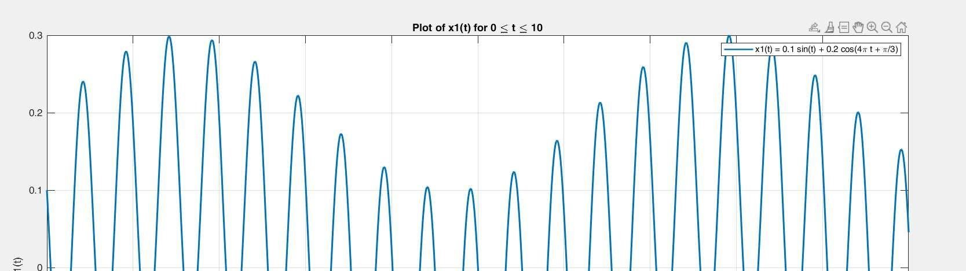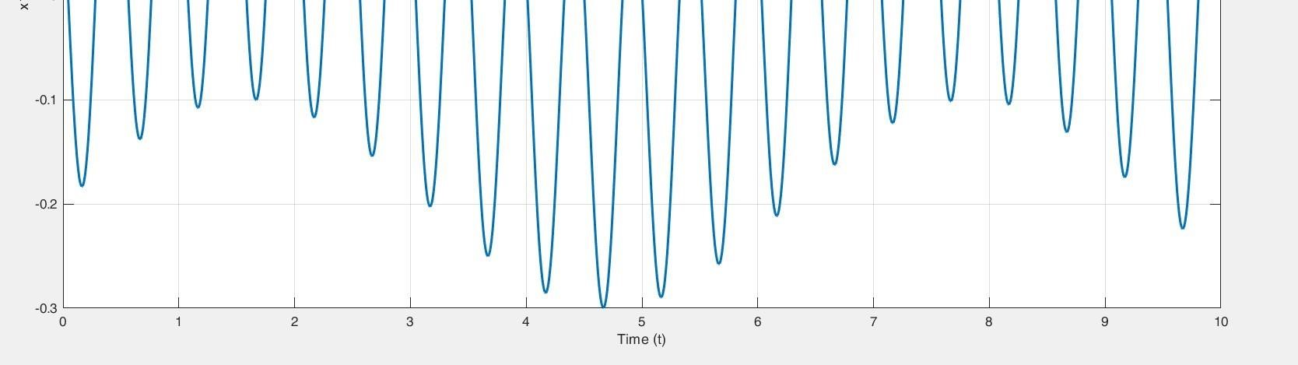

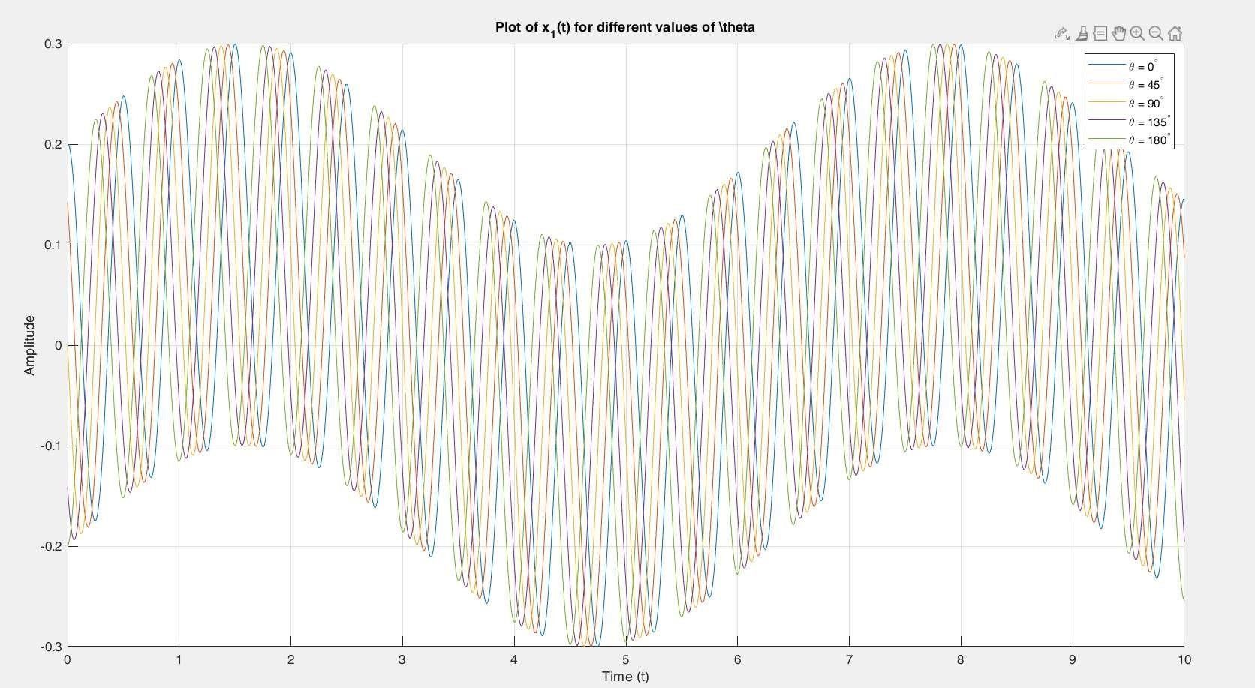b)

c) We know that for a signal to be periodic the ratio of its frequency of all the components must be a rational number but, in the cosine, function we have 4pi rad/s and since 1/4pi is not a rational number therefore is not periodic.

Q2:

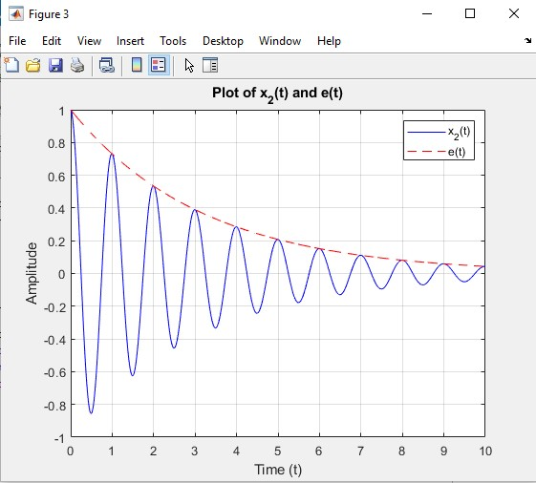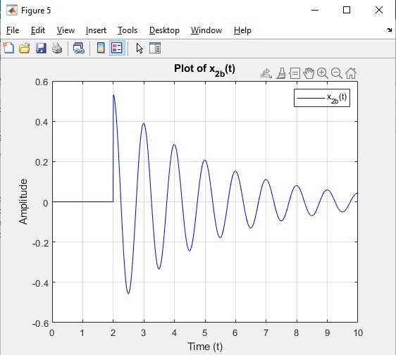

a)

b)

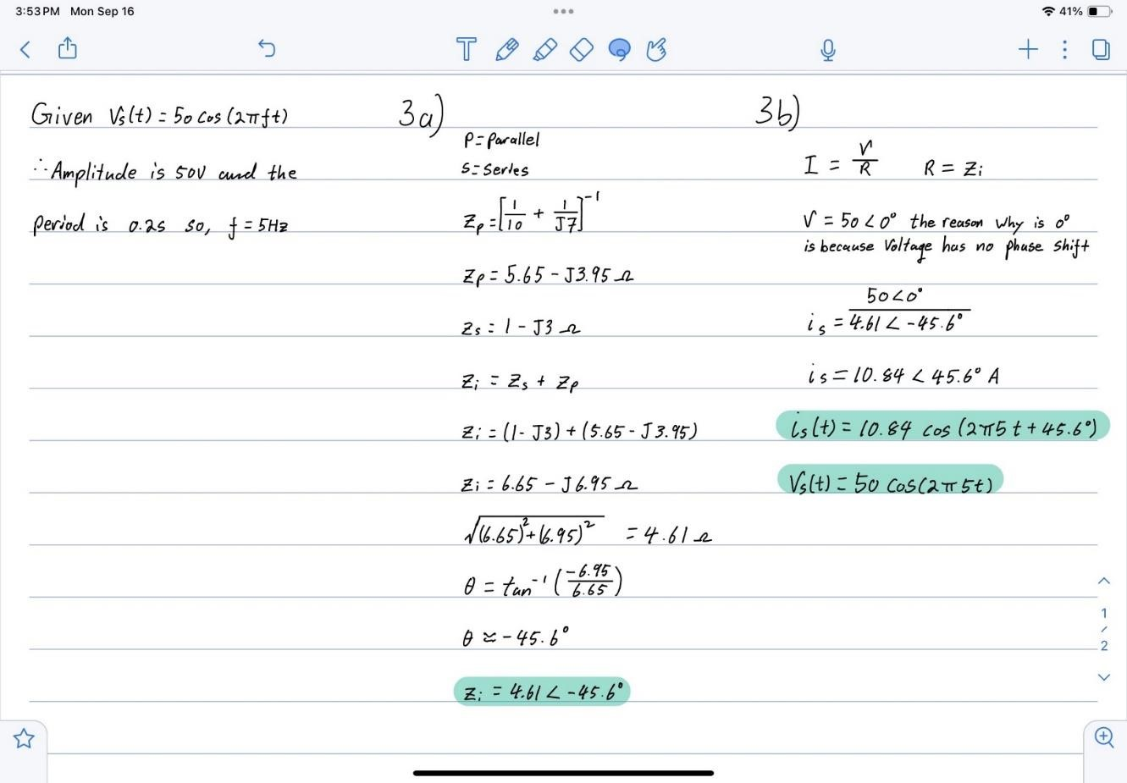Q3:

a)

b)

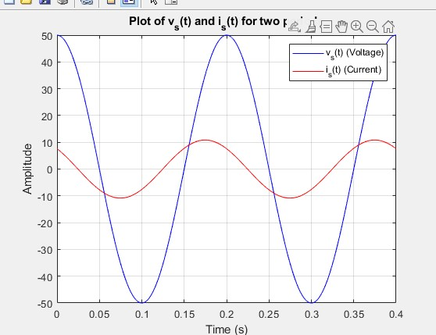

Q4:

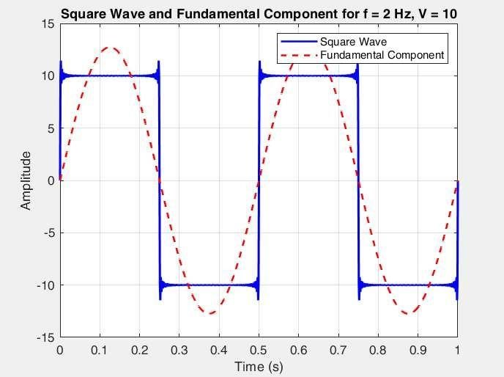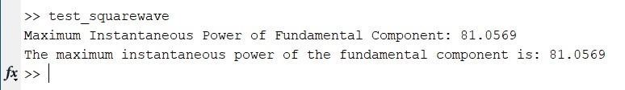

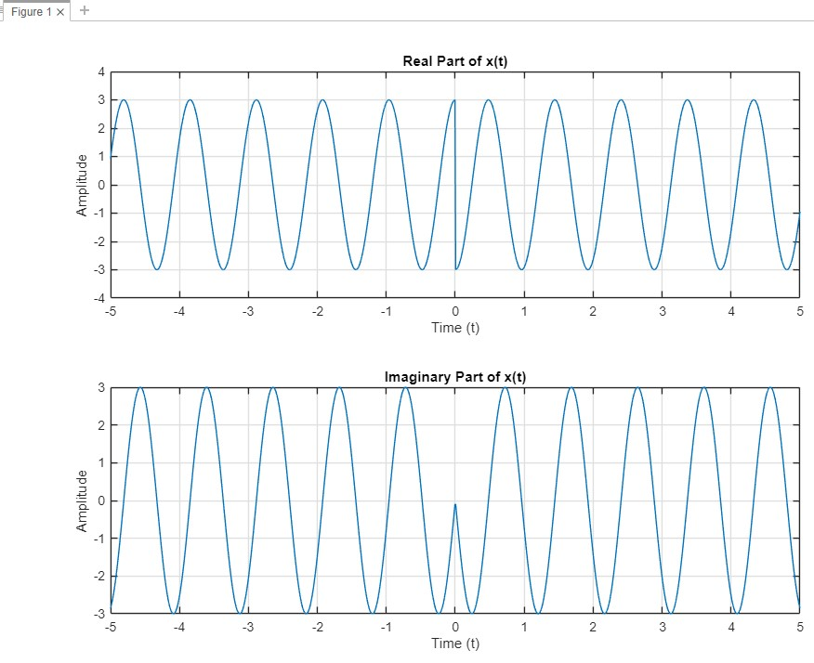Q5:

a)

b)

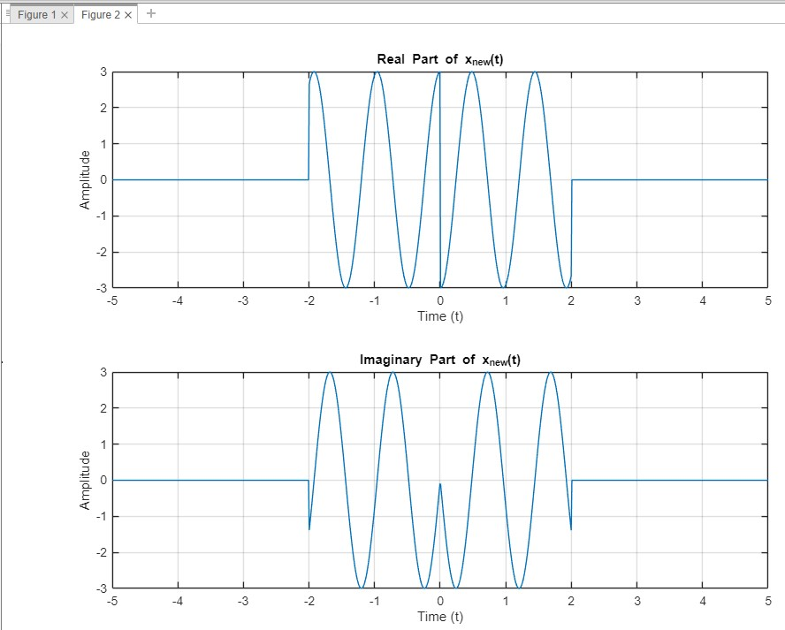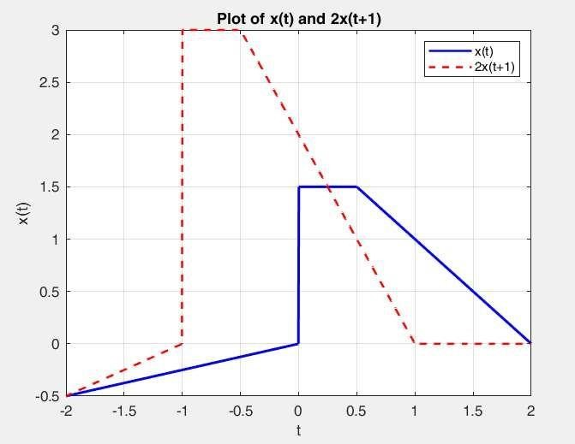

Q6:

Q7:

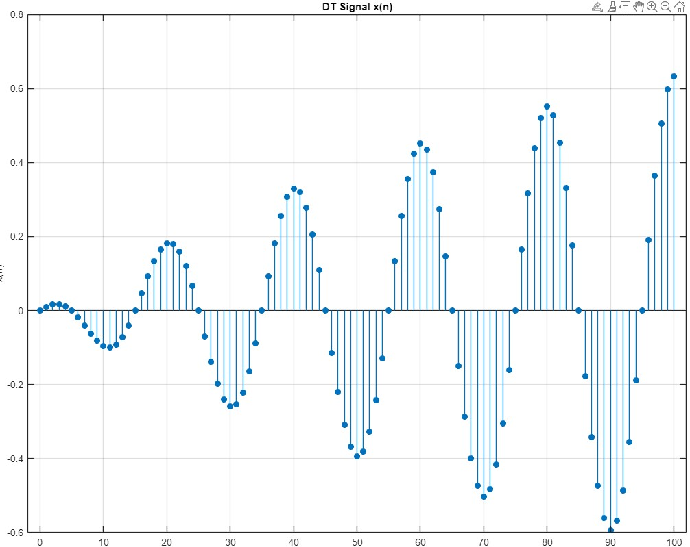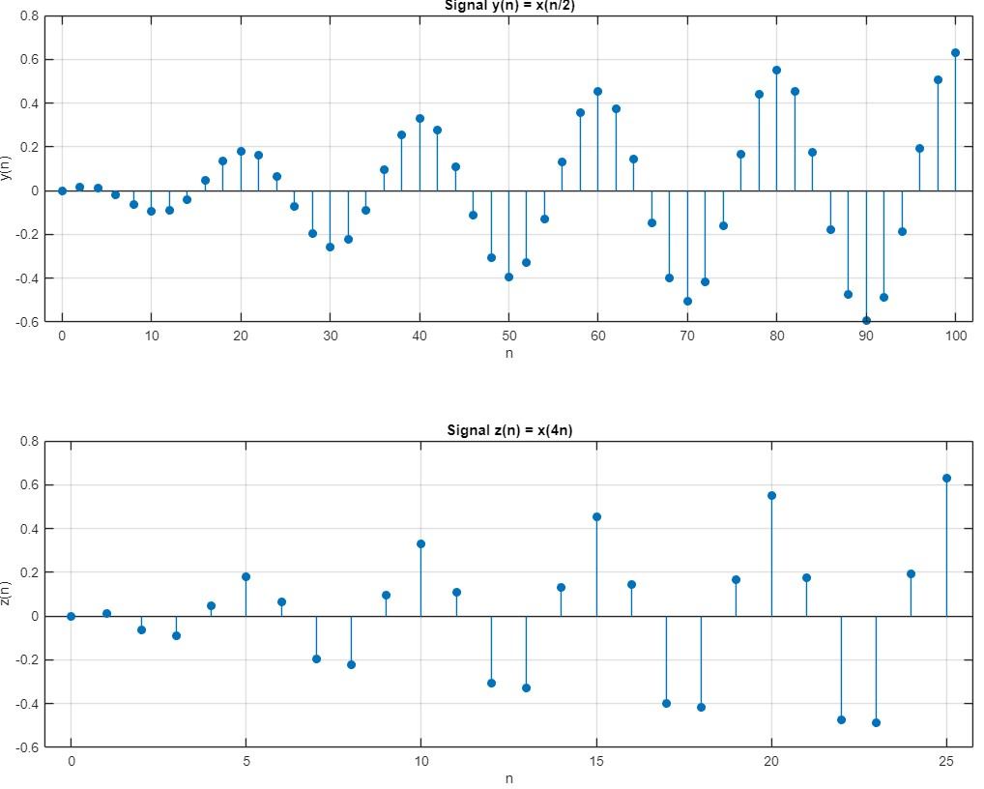

Part 1)

Part 2) Part 3)

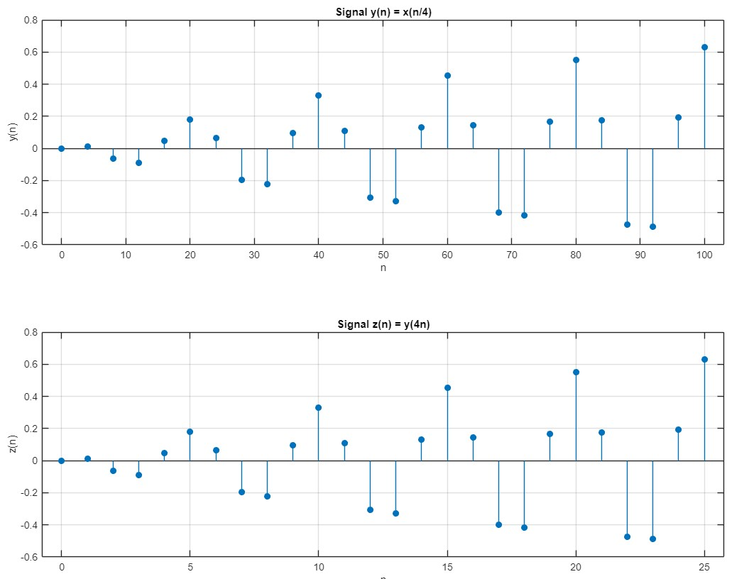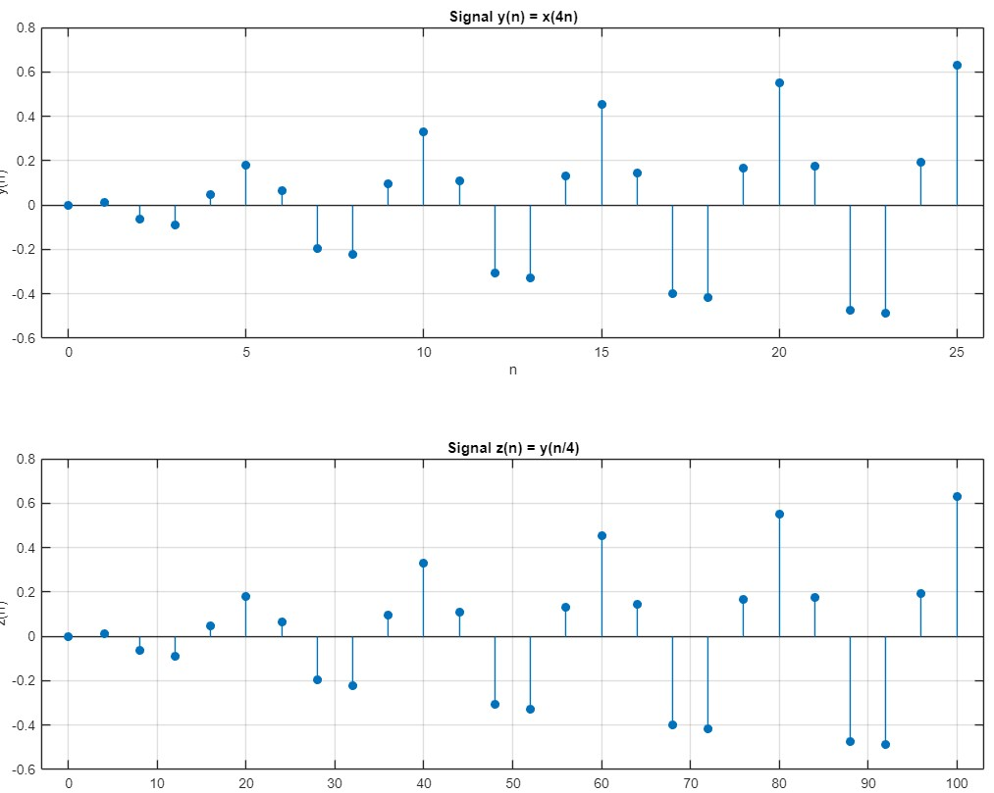

Part 4) As we can see that z(n) in part 3 as a exact copy of x(n), from this piece of information we can say that there are no information are lost, it’s the original signal.

But for part 4 y(n) picked put every fourth value of x(n) so we know that y(n) has less information compared to x(n) so as we generate the z(n) signal, y(n) has missed a lot of information from x(n), therefore z(n) ending up as an incomplete reconstruction compared to x(n).

# Conclusion

In Lab 1, I learned the basic operations of MATLAB, including on how to create and plot functions and signals, include continuous and discrete signals, and implementing signal processing. The objectives of getting familiar with MATLAB, learning basic signal plotting and working with math functions and make the function visualize to examen the signal.

One difficulty I encountered was coding in MATLAB, because the last time I used MATLAB coding was in my first year EECS courses, especially when working with the dot operator for these functions, it was a challenge for me to troubleshoot errors in plotting multiple signals on the same graph and correctly labeled each point.

The lab provided valuable hand on experience in using MATLAB for signal processing tasks, and I now feel a bit more confident in applying some techniques in future labs that includes MATLAB tools.

# Appendix

Q1:

a)

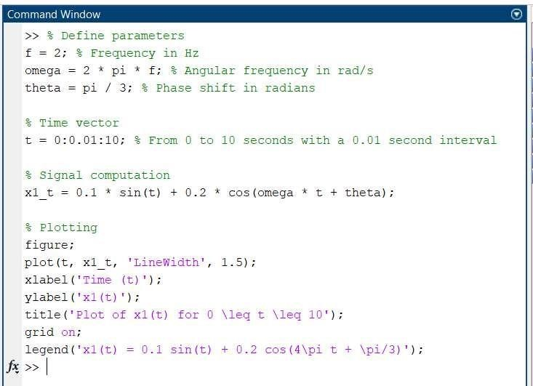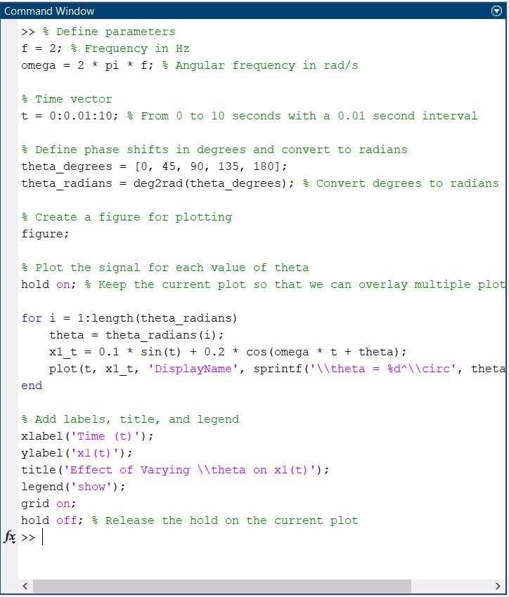

b)

Q2:

a)

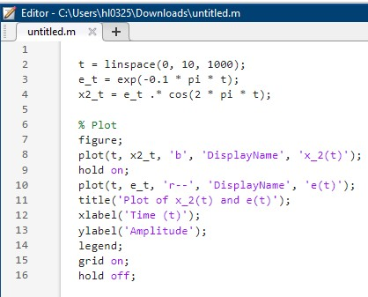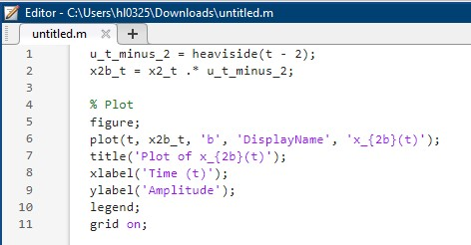

b) Q3:

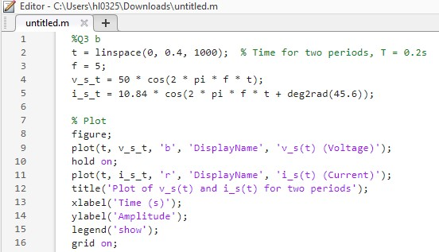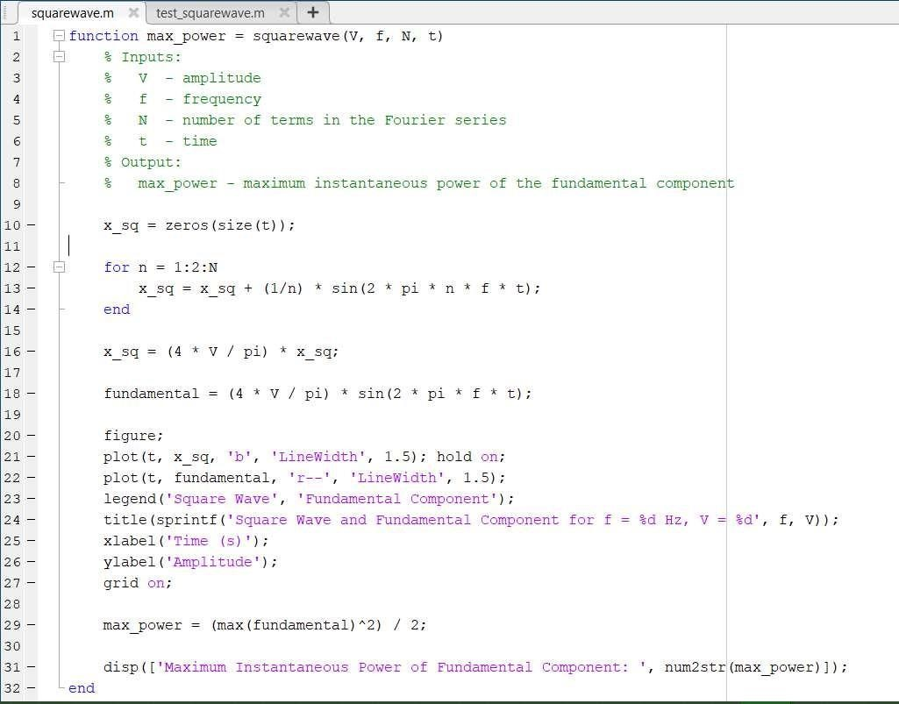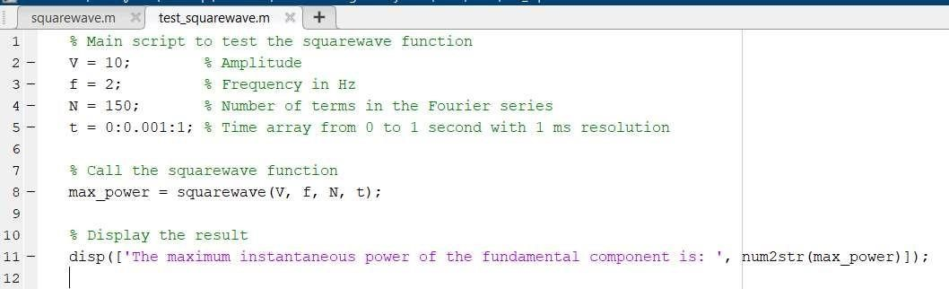

b)

Q4:

Q5:

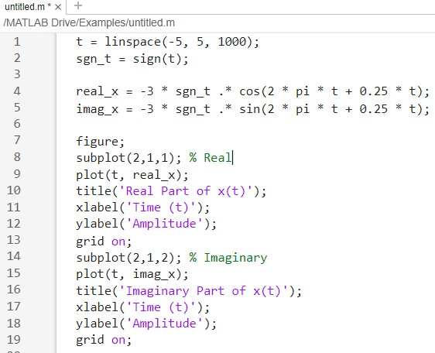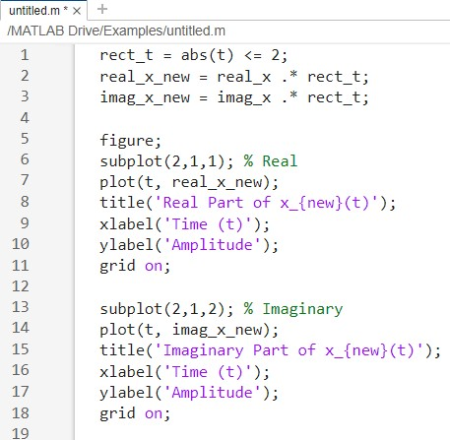

a)

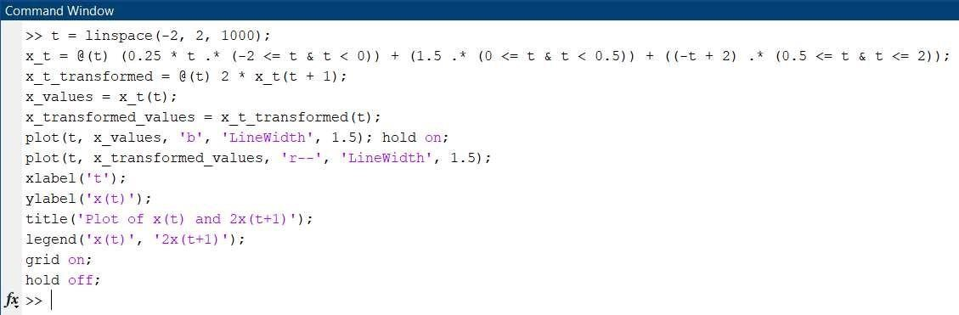b) Q6:

Q7:

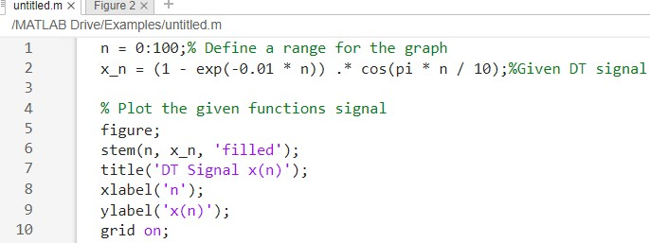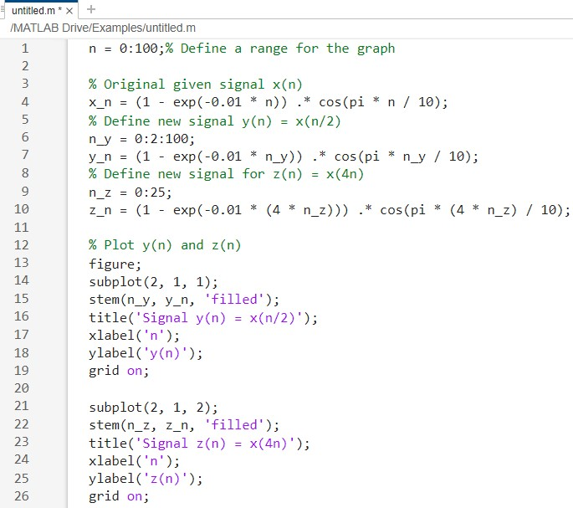

Part 1)

Part 2) Part 3)

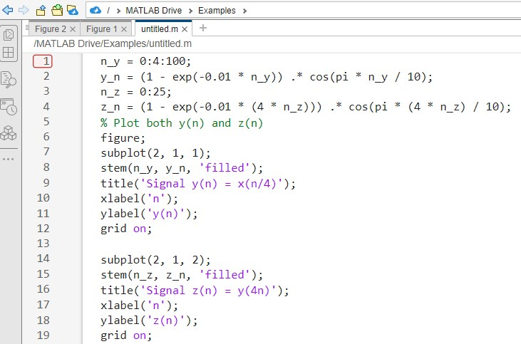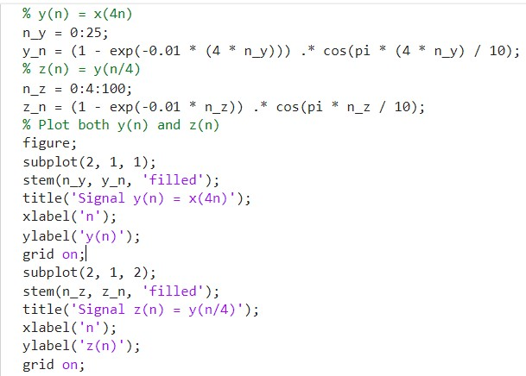

Part 4)